The effects of winter drought on population dynamics and coexistence of native annual forbs

1. Background
   1. Observed diversity declines aboveground in native forbs (serp and non serp) in past 15 years
   2. Observed decrease in winter precipitation across region in the past 15 years
   3. Seedbank is thought to buffer native forb populations against these unfavorable periods however seedling drought tolerance may be more important than germination response if winter drought is the new normal
      1. Preliminary results however show that native forb seedbanks post drought are not depleted, suggesting that either the signal cannot be seen over this short period, or stronger dormancy actually allow forbs to survive winter drought by limiting germination in a good fall before a bad winter
   4. Dormancy in forbs is thought to regulate coexistence in these communities however as important climatic variables change, such as winter rainfall, the beneficial effects of dormancy may also change. In order to understand how populations will respond to these changes, I will study the population dynamics of forbs with different dormancy strategies. I will also look at the community-level response to changes in winter rainfall in order to understand how storage-mediated systems can maintain coexistence in a changing climate.
2. Questions
   1. Q1 – How do annual forb populations respond to variation in winter rainfall and what are the mechanisms underlying this response?
      1. What types of species (low dormancy vs high dormancy) are most likely to be lost under future rainfall scenarios?
      2. How does competition alter population response to winter rainfall?
   2. Q2 – How do coexistence mechanisms at the community level change in response to winter drought?
      1. Do changes in the timing of annual rainfall affect the strength of the community average storage effect?
      2. Do changes in the timing of annual rainfall affect the life stage at which species differences matter?
   3. Q3 - How does the maternal environment affect germination response?
      1. Within a species, do seeds produced in a wet year have higher dormancy than seeds produced in a dry year?
      2. Does a model that bases germination on previous year’s weather make better predictions than models that base germination only on current year’s weather?
3. Hypothesis
   1. H1
      1. H1a – Forbs with higher dormancy will show least resilience to winter drought as indicated through lower population growth rates
      2. In the winter drought treatment, elasticity analysis will reveal that population growth rates are more sensitive to changes in the performance of germinated individuals in high dormancy forbs whereas changes in germination rates will be more important in low dormancy forbs
         1. Conversely, in drought alleviation treatment, population growth rates will be most sensitive to germination rates in both types of forbs
      3. H1c – Projections into the future will show that with increased winter drought, forbs with higher dormancy are at risk of being lost from the system.
   2. H2
      1. H2A - At the community level, plant assemblages in the winter drought treatment will show a weaker storage effect as compared to the alleviated winter drought treatment, indicating weaker coexistence.
      2. H2B - Under the winter drought treatment a larger proportion of the storage effect will be attributed to differences between species in seedling stage than to differences in germination rates.
   3. H3
      1. H3A – Within a species, dormancy will be stronger in seeds produced in the wet treatment than in drought treatment
      2. H3B – The model in which germination depends on the previous year’s rainfall will better predict plant cover over 15 years than the model that depends only on current year’s rainfall
4. Methods
   1. Treatments
      1. Control (normal background rainfall)
      2. Drought (50% less rainfall)
      3. Alleviation of winter drought treatment
   2. Study species
      1. Low dormancy
      2. High dormancy
   3. Implementation
      1. Sowing aboveground seed
      2. Burying seed bags
5. Tests
   1. H1 – Population level response to winter drought across dormancy strengths
      1. H1A - Compare population growth rates between forbs in each treatment by parameterizing annual plant model
      2. H1B - Elasticity analysis to evaluate life stage importance to population growth rate
      3. H1C - Parameterize annual plant model with environmental stochasticity for different dormancy strengths and project out into the future to test which will be lost from system
         1. Could also do a life table analysis
   2. H2 – Use demographic data to parameterize storage effect model for community (ala Angert et al.) and compare:
      1. H2A - Strength of storage effect between treatments
      2. H2B - Life stage partitioning of the storage effect between treatments
   3. H3 – Dormancy predictions
      1. H3A – Collect seeds from each treatment and conduct germination trials and compare germination %
      2. H3B – Build model with germination as a function of the previous year’s rainfall and compare predictions of plant cover trends to model in which germination depends on current year type. (Tielborger vs Levine)
         1. 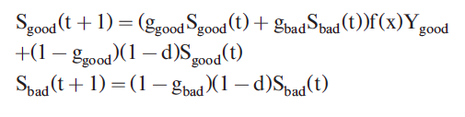Tielborger’s model
            1. In good years
            2. In bad years

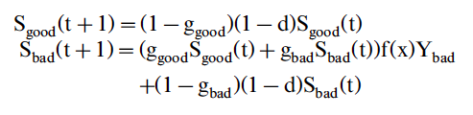

* + - * 1. Good and bad years vary stochastic with

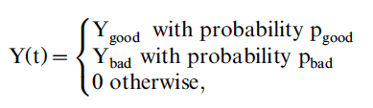

* + - * 1. The function f(x) determines the survival probability of seedlings and depends on the total density of seedlings x = ggoodSgood + gbadSbad
        2. Paper shows that the solution ggood<gbad is better than when ggood=gbad
      1. 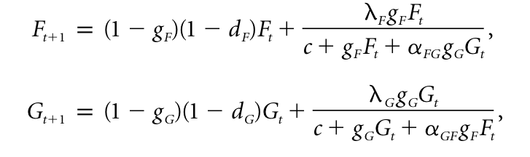Levine’s Model
         1. In this model (which here is for a grass and a forb competing but can also just look at forbs) g and lambda change depending on the favorability of the year, ultimately with higher germination in good years and lower germination in bad years